User Interface: DIY Tool Exchange

Chris Patterson, SWDV-691 FA/2

# Foundation

The personas are a personification of main user types that would be using this site. For demonstration purposes, they can be ranked as the "Apprentice", "Journeyman", and "Master". As a stretch item, the "Feedback" persona would be added:

* The Apprentice is a newbie; they probably have no tools to share (or very few). They will mostly be interested in borrowing / renting tools. They may be attempting a DIY project for the first time. They might require extra guidance on what the purpose and function of each tool is.
* The Journeyman is a more seasoned DIY'er. They've "been there and done that" a few times. They will probably have tools to loan, as well as need to borrow or rent tools. They will be a little more knowledgeable than The Apprentice, but still might need some direction when it comes to tools. These users will be the backbone of the application, as they will occupy multiple roles.
* The Master will have a vast collection of tools and be a seasoned DIY'er or even a pro contractor. Most likely they'll have lots of tools to loan, and rarely need to borrow tools. Most likely, the Master will need to be incentivized the most (of any user type) to use the application.
* The Feedback persona could be anyone of any skill level. This person likes to make their opinion known loud and clear.

# Personas

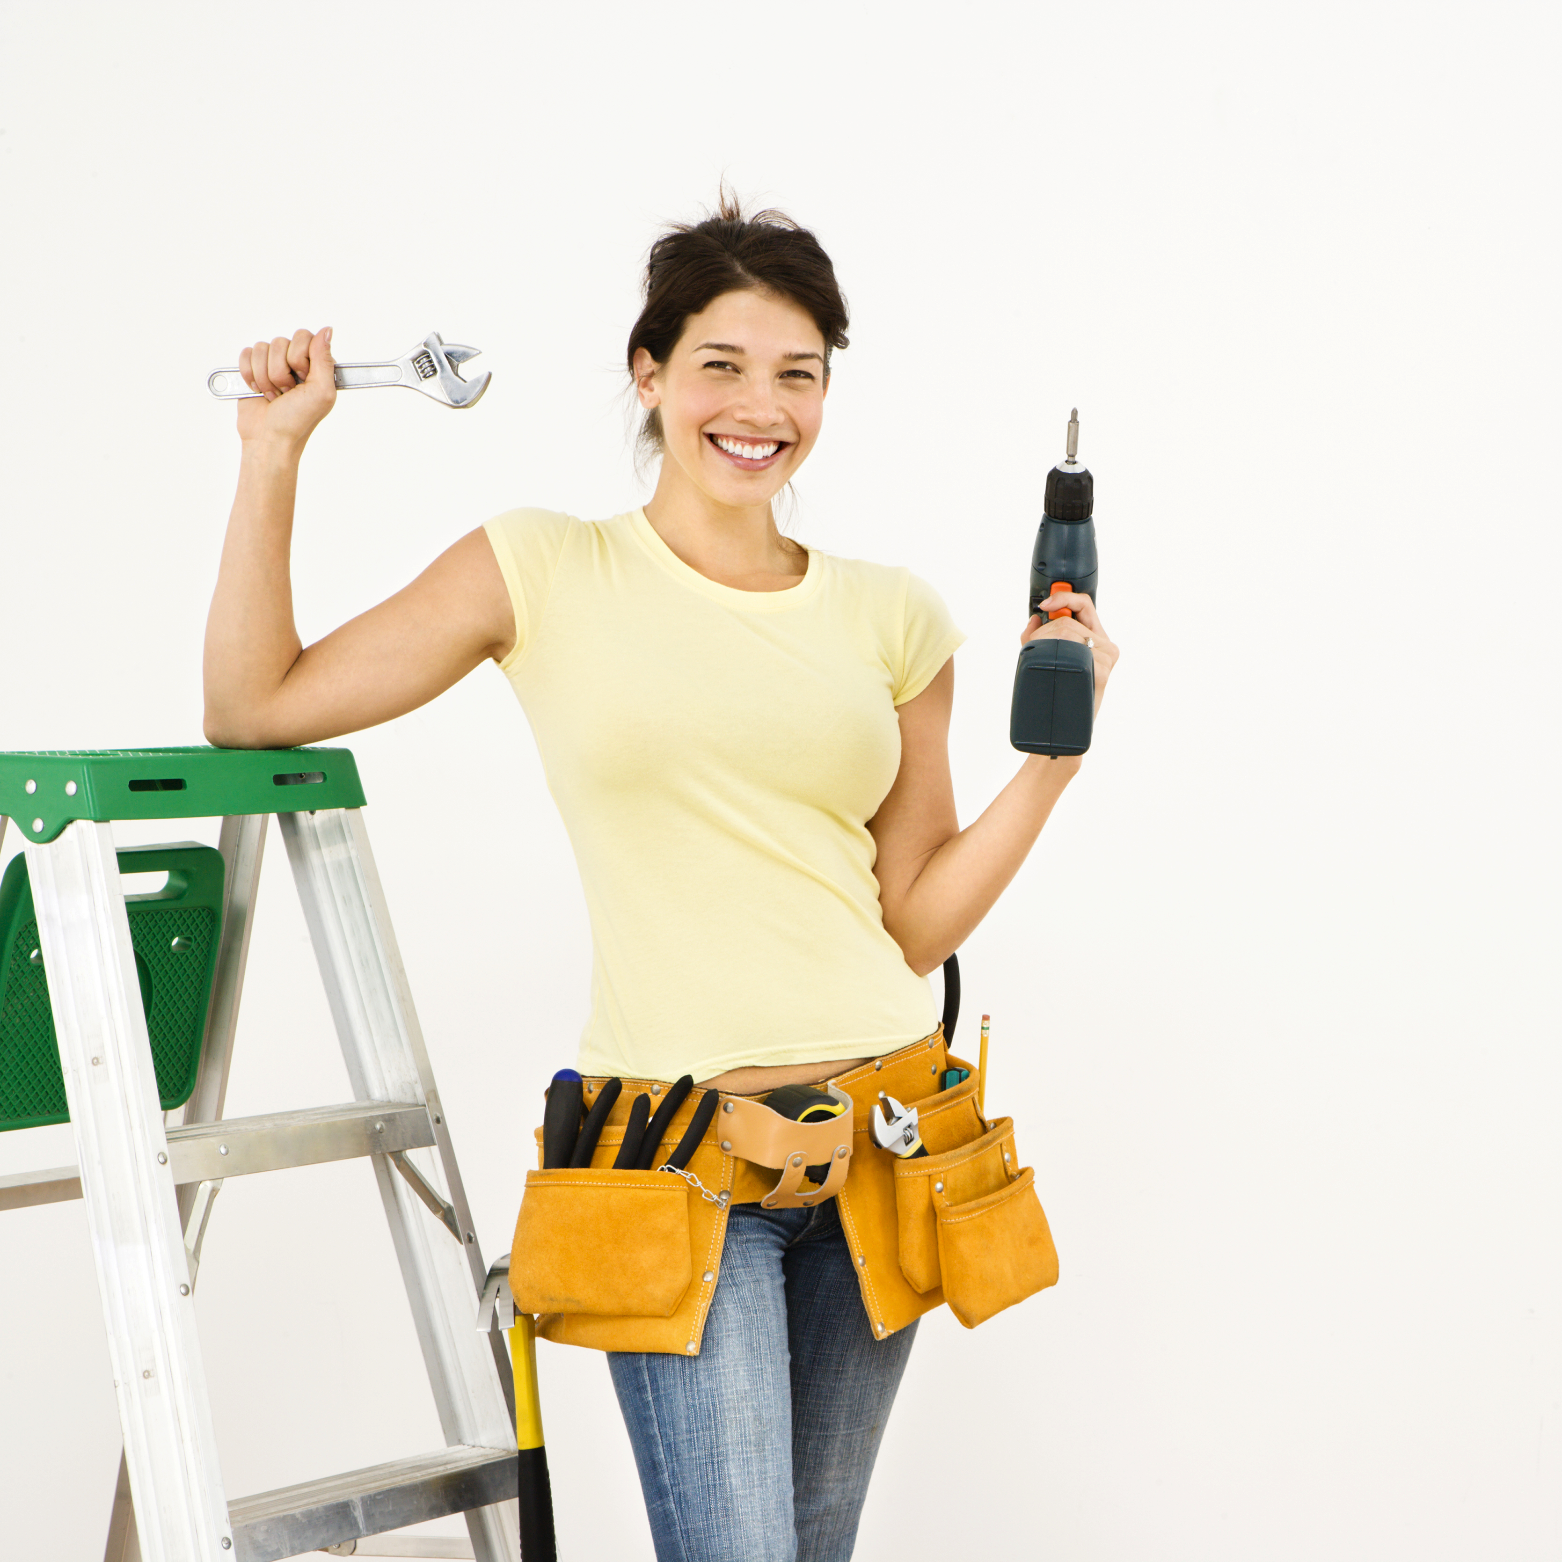

First up is Sue Newbie. She would be the equivalent of our "apprentice" classification. Sue is 28, single, and just bought her first home a month ago. Sue is educated and works in a professional career, but would like to try her hand at tackling some projects around her new home. Sue does not have an extensive tool collection, and depends on videos and articles found on the web to guide her through her projects. Sue would mostly be a borrower within the DIY Tool Exchange app.

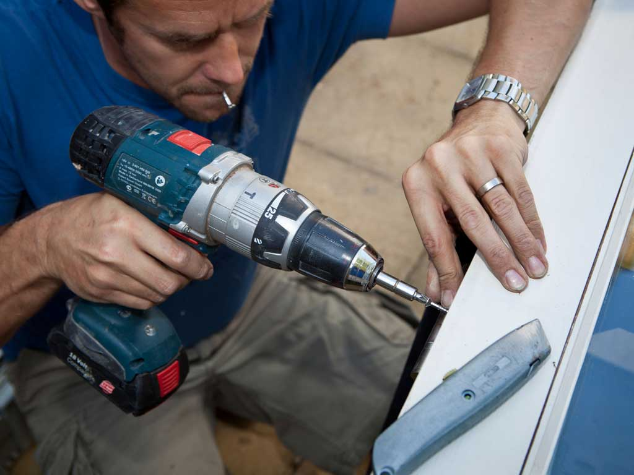

Next up is Ted Middleman. He's our "journeyman" user. Ted is 45, married with two kids, and has been a homeowner for 15 years. Ted's been there and done that a few times. Last summer he even built his own deck. Ted has a pretty good tool collection, but often finds himself needing certain tools that he'd rather not buy for a one-time use. Ted learned everything he needed to know about home improvement in High School shop class. He doesn't need videos or instructions to get through a project, or so he says. Ted would be a borrower and a lender when using the DIY Tool Exchange app.



Next, we have Bob d'Builder. He's our "master" user. Bob is 40, married with three kids, and owns his own professional handyman service. Bob has a great sense of community, and likes to help out his neighbors when he can. He also knows that every contact he makes is a potential future customer. Aside from that, Bob has an extensive tool collection. Rarely does he need to run out and buy a new tool to finish a job. Bob sees the DIY Tool Exchange as a good way to cycle out older tools by marking them as available for purchase. On the rare occasion he might need to borrow a tool from one of the other users.



Lastly we have Freddy Feedback. He can be any level of DIY'er, but he also has another hobby. Wherever he goes and whatever he does, Freddy never walks out the door of an establishment without first leaving a review on his favorite review sites. Freddy considers it his civic duty to let others know about his experience.